**Project Report**

**Topic: Effects of COVID in New Zealand**

By group Track Stars：

Zahid Khan

Pei (Perry) li

Jiani (Norie) Wu

Kaishun (Ted) Yang

**Introduction：**

The covid-19 epidemic is the biggest crisis the world has faced since World War II and has had a huge impact on the world, including people's psychology and livelihoods, economic growth and employment, and national governance. Our team will analyze the impact of the total number of covid cases for vaccinations, crime rate, deaths, agricultural and GDP (Gross Domestic Product) in New Zealand.

**Target:**

1. Find the change of crime rate before and after covid, and thus find out how much influence covid has caused on the general safety in New Zealand.
2. Find the change of agriculture(livestock) before and after covid, and thus find out how much influence covid has caused on the numbers of livestock.
3. Find the change of GDP (Gross Domestic Product) before and after covid, and analyse the economic impact of the covid outbreak on New Zealand.
4. Find the change of death rate before and after covid, analysis of mortality caused by covid in New Zealand.
5. Find the number of Vaccines Administered before and after covid, Analysis of changes in people's willingness to receive vaccines during the covid.

**Data sources:**

Covid Data:

Ministry of Health NZ (Git Repo)

<https://github.com/minhealthnz/nz-covid-data>

Vaccination Data:

Ministry of Health NZ (Git Repo)

<https://github.com/minhealthnz/nz-covid-data>

Crime Rate:

New Zealand Police statistics

<https://www.police.govt.nz/about-us/publications-statistics/data-and-statistics?nondesktop>

Death Rate:

Ministry of Health NZ (Git Repo)

<https://github.com/minhealthnz/nz-covid-data>

Agriculture:

Before Covid:

https://www.stats.govt.nz/information-releases/agricultural-production-statistics-june-2019-final/?fbclid=IwAR2WAR9QR33HcLXF7Nt-JAZZRukfgQiDJhFAukYjOz_HKqKOeQ8kJzxky3c

After Covid:

<https://www.stats.govt.nz/information-releases/agricultural-production-statistics-year-to-june-2021-final/?fbclid=IwAR04a29AGmveWZyfI0V9i9yD-5OP68RAazrGrpmOWMw4GRZKpane8jcWjzA>

GDP:

https://www.stats.govt.nz/information-releases/gross-domestic-product-june-2022-quarter/?fbclid=IwAR1bfYeCwfOSBIp97SkhGlWFzReIxGYD5Q7Fl5jaCmCf3yLqgXgGKbgwjIw

**Wrangling difficulties:**

**For Crime Rate and covid cases:**

1. Column names, data types do not always match.

2. Merging of data frames does not always work with joins.

3. Values must be manually modified to match another data frame.

4. Ggplot configuration is cumbersome to setup 5 data maps require more packages to produce.

**For Agriculture:**

1. Excel form import data is some column name garbled，so we had to set new columns names.
2. There are a lot of N/A in the data table, and we need to do some row and column deletions.
3. Need to convert chr type of numbers to numeric.
4. Need to replace the data in the table that is invalid for suppressed and absent.

**For GDP:**

1. The formatting of the data tables was not standardized, and many unnecessary elements needed to be removed.
2. Quarterly data is not conducive to sorting the correct time, and sorting the month requires changing the data type.
3. Integrate wide tables into long tables to create graphs that are easier to compare and observe.
4. There are missing years in the table, which need to add the year into the table.

**For Death Rate:**

**For Vaccines Administered:**

**Achievements:**

**For Crime Rate and covid cases:**

**Target:** Find the change of crime rate before and after covid, and thus find out how much influence covid has caused on the general safety in New Zealand.

**Result:**

1. Compared to the pre-outbreak period, the crime rate increased significantly after the outbreak of COVID.

2. Until January 2022, the daily number of cases in New Zealand decreased almost close to 0. After January 2022, the daily number of cases in New Zealand suddenly rose straight up to the peak of 25,000, and then began to decline, and so far, the number of cases is still showing a downward trend.

**Graph:**

1.

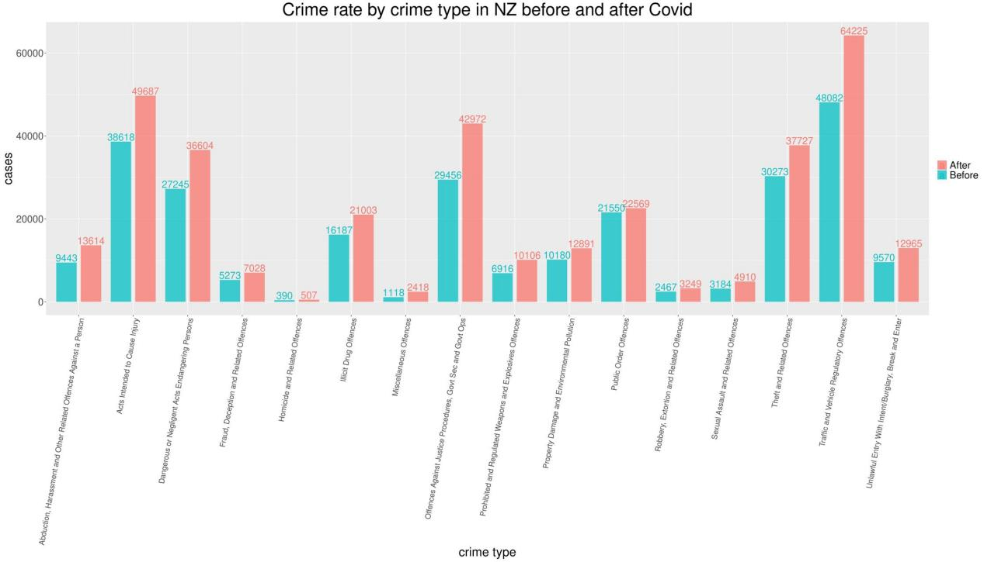

2.

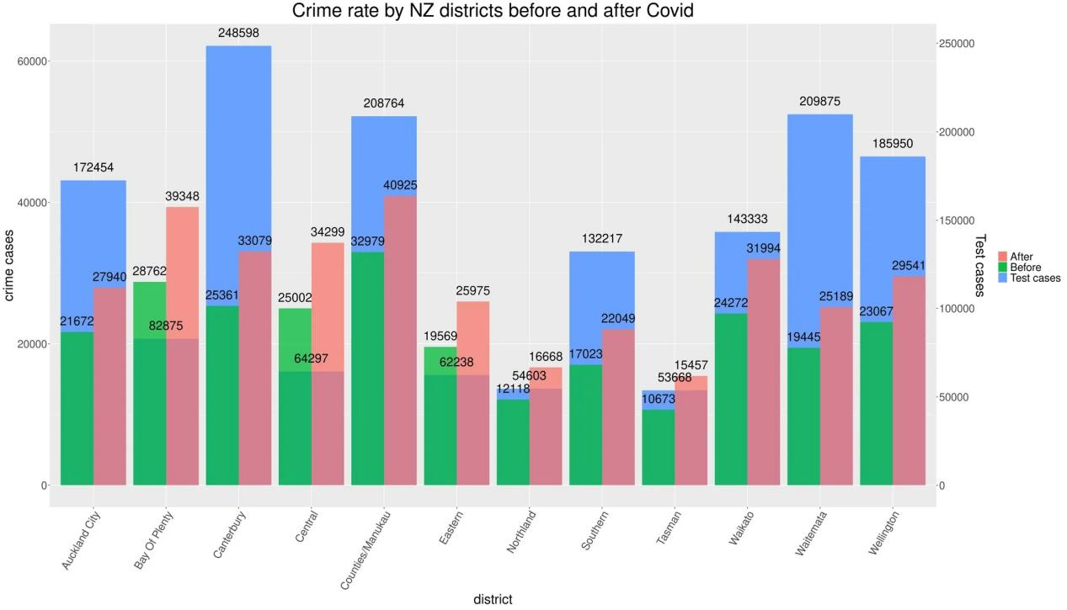

3.

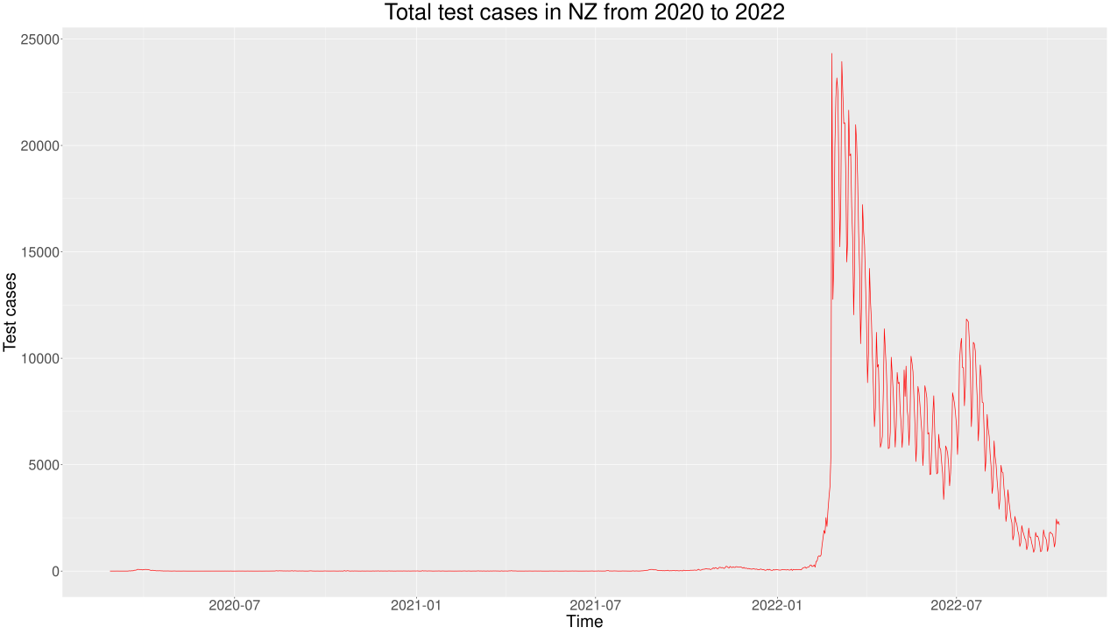

**For Agriculture:**

**Target:** Find the change of agriculture(livestock) before and after covid, and thus find out how much influence covid has caused on the numbers of livestock.

**Result:**

The total number of livestock did not change much before and after the outbreak, and except for the number of sheep, which decreased slightly in different cities in New Zealand after the outbreak, the total number of livestock cow cattle, beef and deer did not decrease but increased in most of the (75%) cities in New Zealand after the outbreak.

**Graph:**

**For GDP:**

**Target:** Find the change of GDP (Gross Domestic Product) before and after covid, analyse the economic impact of the covid outbreak on New Zealand.

**Result:**

GDP decreased significantly during the New Zealand lockdown but bounced back when the lockdown is over. Health GDP has been rising gradually, people will pay more attention to health because of the epidemic.

In short, preventive and control measures for the outbreak have a greater impact on GDP than the virus itself.

**Graph:**

1.

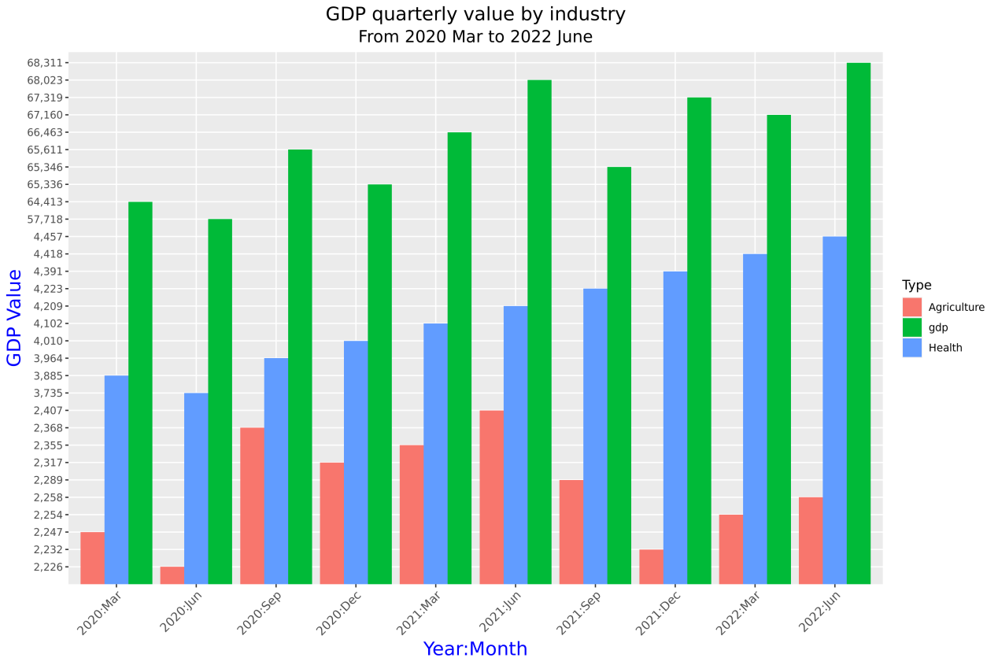

2.

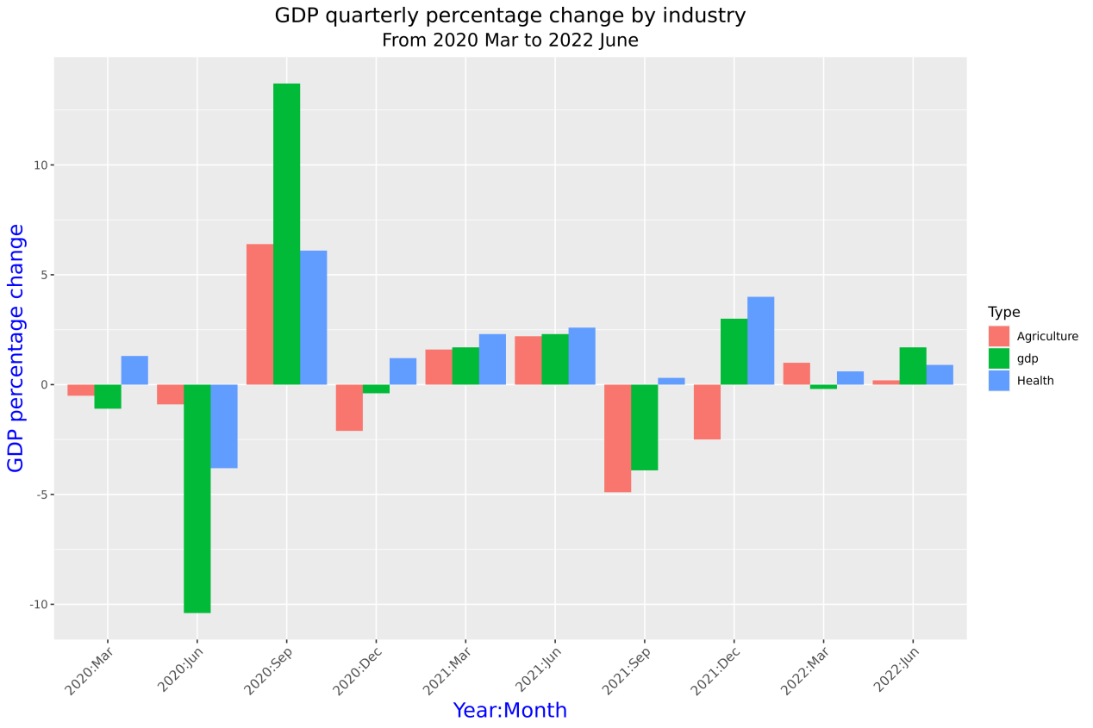

**For Death Rate:**

**Target:** Find the change of death rate before and after covid, analysis of mortality caused by covid in New Zealand.

**Result:**

Mortality is strongly correlated with cases that test positive. The number of deaths due to the covid is about 0.001 percent of the total test results. From February to August 2022 is the time when New Zealand is most affected by the virus, with a significant increase in tests and deaths during this period. And it ends after September.

**Graph:**

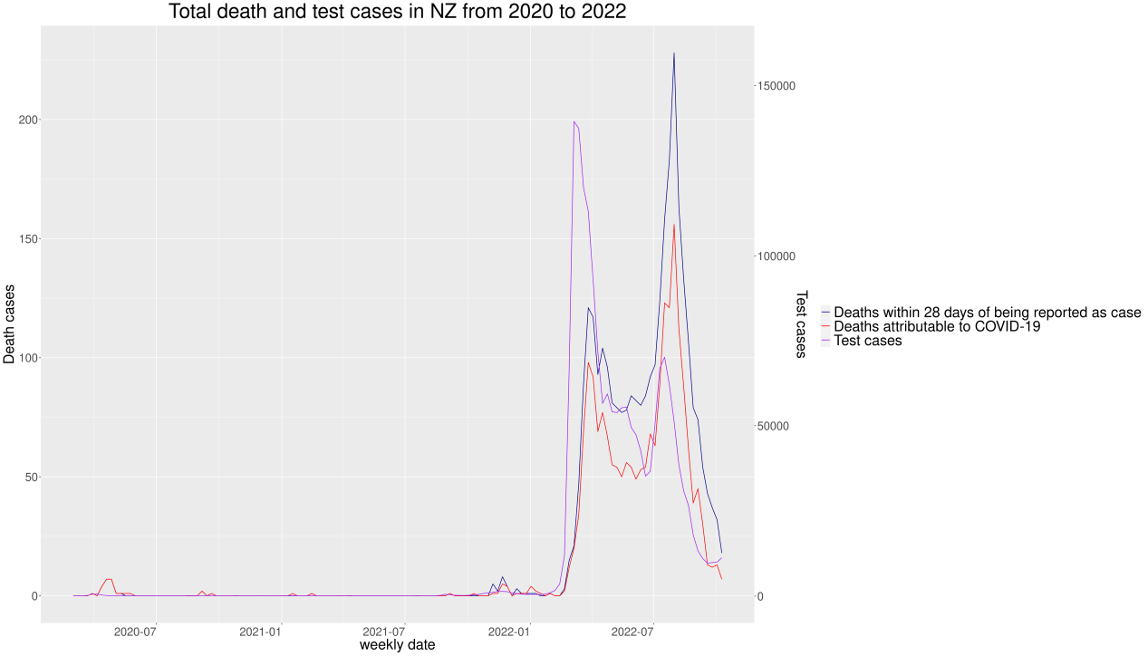

**For Vaccinations:**

**Target:** Find the number of Vaccines Administered before and after covid, Analysis of changes in people's willingness to receive vaccines during the covid.

**Result:**

In 2021, the number of vaccinations is generally on the rise. The national trends in vaccination numbers are all roughly the same. The Auckland region has the highest number of vaccinations by region in New Zealand. September is a peak month for the number of vaccinations. There was a significant drop in October.

**Graph:**

1.

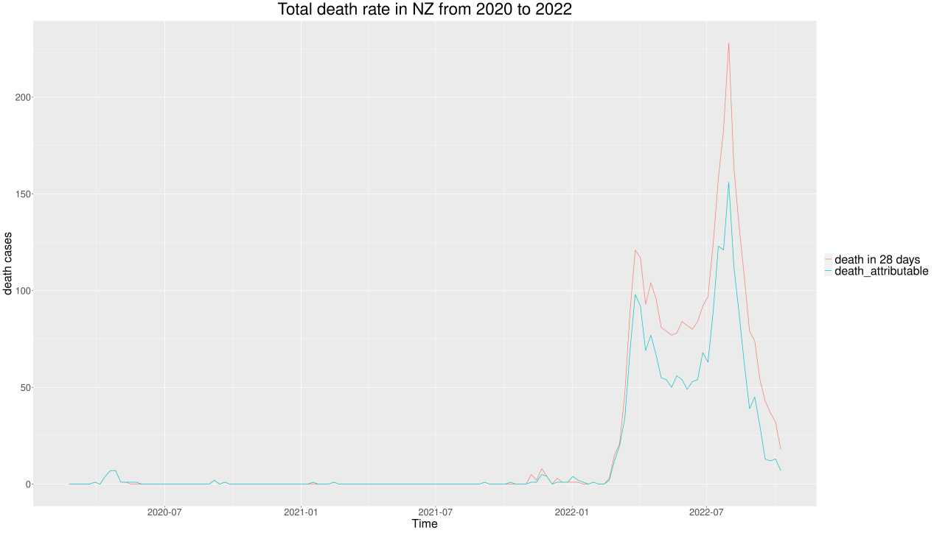

2.

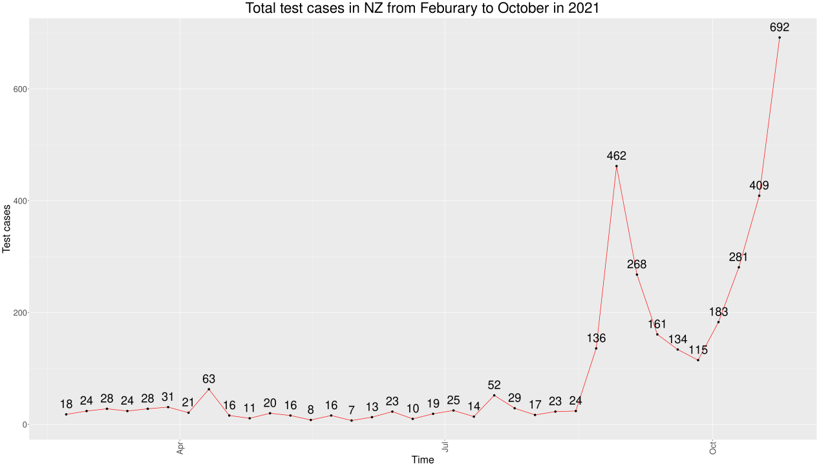

3.

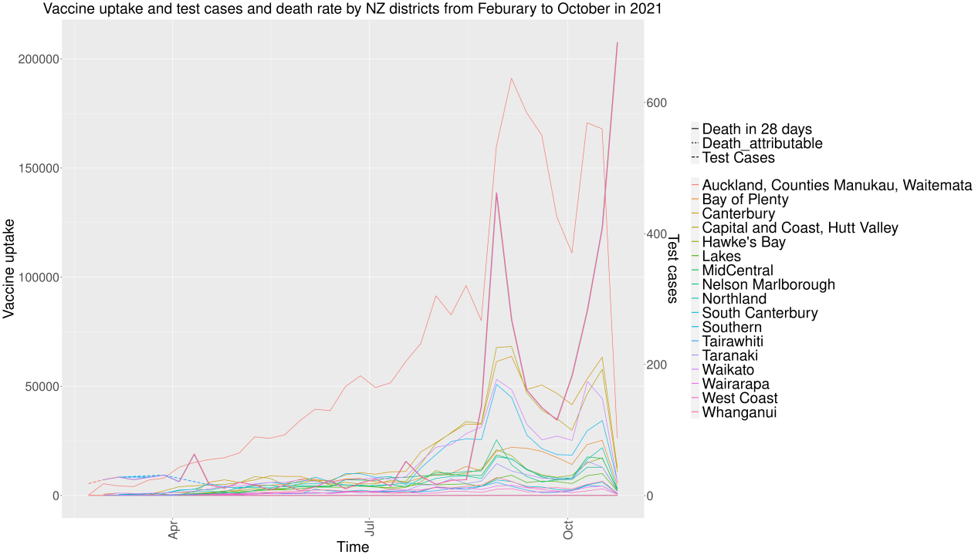

4.

